**机密★启用前**

**四川省2022年普通高校对口招生统一考试**

**英语**

**本试题卷分第Ⅰ卷（共两部分）和第Ⅱ卷（共三节）。第Ⅰ卷1-10页，第Ⅱ卷11-12页，共12页。考生作答时，须将答案答在答题卡上，在本试题卷、草稿纸上答题无效。满分100分。考试时间120分钟。考试结束后，将本试题卷、答题卡和草稿纸一并交回。**

**第Ⅰ卷（共两部分 满分70分）**

**注意事项：**

**1. 必须使用2B铅笔在答题卡上将所选答案对应的标号涂黑。**

**2. 第Ⅰ卷共两部分，满分70分。**

第一部分 英语知识运用（共两节；满分30分）

第一节单项选择（共15小题；每小题1分，满分15分）从A、B、C、D四个选项中，选出可以填入空白处的最佳选项。

1. —You look great in that pink dress.

—________

A. Where did you buy it? B. You’re welcome.

C. Thank you. D. Enjoy yourself.

【答案】C

【详解】句意：——你穿那条粉红色的裙子真好看。——谢谢。

考查情景交际。Where did you buy it? 你在哪里买的？ You’re welcome.不客气。Thank you.谢谢。 Enjoy yourself.玩得开心。根据西方的文化习惯，当听到人家的赞美时要表示感谢，故选C 。

2. I had ________ big lunch at my friend’s yesterday.

A. a B. an C. / D. the

【答案】A

【详解】句意：昨天我在我朋友家吃了一顿丰盛的午餐。

考查冠词辨析。不定冠词a后跟辅音音素开头的词如big, 不定冠词an后跟元音音素开头的词如egg，the +名词表特指。had a big lunch 吃一顿丰盛的午餐。故选A。

3. Up to now, no one except Eric and Chris ________ the possible danger.

A. have realized B. has realized C. is realizing D. are realizing

【答案】B

【详解】句意：到目前为止，除了埃里克和克里斯，没有人已经认识到可能的危险。

考查时态。Up to now到目前为止，它常和现在完成时（have/has +过去分词）连用，此外，no one except---作主语时，谓语的数要跟no one保持一致，即谓语用单数，综合以上要求，故选B。

4. John, you should learn to behave ________ at the dinner party.

A. you B. yours C. yourself D. yourselves

【答案】C

【详解】句意：约翰，你应该在正餐聚会学会守规矩。

考查代词辨析。you你，作主语或宾语；yours你们的，名词性物主代词； yourself你自己， 反身代词；yourselves你们自己， 反身代词。behave yourself守规矩，主语是you，指前面的John，意为你，所以后面对应的反身代词用yourself表你自己。故选C。

5. Do you know that the concert is scheduled ________ the evening of August 5?

A. on B. in C. at D. of

【答案】A

【详解】句意：你知道音乐会被安排在8月5日的晚上吗？

考查介词辨析。on+具体的某一天或某一天的上午、下午或晚上；in+较长的时间，如：世纪、朝代、年、季节、月份以及泛指上午、下午、晚上；at+具体的时刻，如at 4 o’clock, at 4:17；of表所属关系。在8月5日的晚上要用介词on。故选A。

6. Do be more careful next time, ________ you?

A. don’t B. aren’t C. do D. will

【答案】D

【详解】句意：下次一定要更加小心，好吗？

考查祈使句的反意疑问句的用法。祈使句，will you（好吗）? 来征询别人的意见，故选D。

7. ________ terrible weather we’ re having these days!

A. What B. How C. What a D. How a

【答案】A

【详解】句意：这些天的天气多么糟糕!

考查感叹句。What修饰的中心词是名词，所以What + a/an + adj. + n（单数可数）+主谓! What +adj. +n (不可数或复数)+主谓!而How修饰的中心词是副词或形容词，所以How + adj./adv. +主谓! weather是不可数名词，所以用 What +adj. +n (不可数或复数)+主谓!，故选A。

8. —Would you like to ________ now, sir?

—A glass of orange juice and a beef sandwich, please.

1. pay B. drink C. leave D. order

【答案】D

【详解】句意：—先生，你愿意现在就下单吗？ —请给我一杯橙汁和一个牛肉三明治。

考查动词辨析。pay支付；drink喝；leave离开，留下；order订，下单。根据“A glass of orange juice and a beef sandwich, please.”可知，这是服务员请顾客下单，故选D。

9. Do you know ________?

A. where does Sally live B. where Sally lives

C. where lives Sally D. Sally lives where

【答案】B

【详解】句意：你知道萨莉住在哪里吗？

考查宾语从句。宾语从句要用陈述句语序，即用where Sally lives， 再如I don’t know what she likes.。故选B。

10. Tony often helps his classmates ________ he is very busy.

A. if B. when C. since D. though

【答案】D

【详解】句意：虽然托尼很忙，他经常帮助他的同学。

考查连词辨析。if 如果；when当；since自从，因为；though虽然。“帮助他的同学”与“很忙”是让步关系，though符合语境。故选D。

11. It’s no use ________ all the time.

A. complaining B. complained C. to complain D. complain

【答案】A

【详解】句意：一直抱怨是没有用的。

考查It作形式主语的句型。 It’s no use doing sth. 表 “做某事是没有用的。”，It 是形式主语，真正的主语是doing sth， complaining符合语境。故选A。

12. Every morning I eat all the breakfast food ________ is prepared by Mom.

A. what B. which C. that D. as

【答案】C

【详解】句意：每天早上我吃完妈妈准备的所有早餐。

考查定语从句。先行词 the breakfast food被不定代词all修饰，设空处在后面的定语从句指物（the breakfast food），作主语，要用that。故选C。

13. I’m truly ________ for what you’ve done for me.

A. welcome B. grateful C. pleasant D. willing

【答案】B

【详解】句意：我真的感谢你为我所做的一切。

考查形容词辨析。welcome欢迎的；grateful感激的，感谢的；pleasant愉快的；willing愿意的。我真的感谢，用grateful。故选B。

14. My neighbor often ________ my home and children while I’m away.

A. looks for B. looks after C. looks at D. looks into

【答案】B

【详解】句意：我邻居经常在我不在的时候照顾我的家和孩子。

考查动词短语辨析。look for寻找；look after照顾，照看；look at看；look into向里面看，调查。照顾我的家和孩子，用looks after。故选B。

15. ________ how to deal with the situation.

A. Only knows Mary B. Mary knows only

C. Only does Mary know D. Only Mary knows

【答案】D

【详解】句意：只有玛丽知道怎样处理这种情况。

考查单词Only的用法。Only修饰名词要放在名词的前面，如Only my friend can understand me.。故选D。

第二节 语言应用（共10小题；每小题1.5分，满分15分）

Part A 根据下列图片所提供的信息，从16~22题所给的三个选项（A、B、C）中，选出最佳选项。

16. If you’d like to visit Star of India, you should ________.

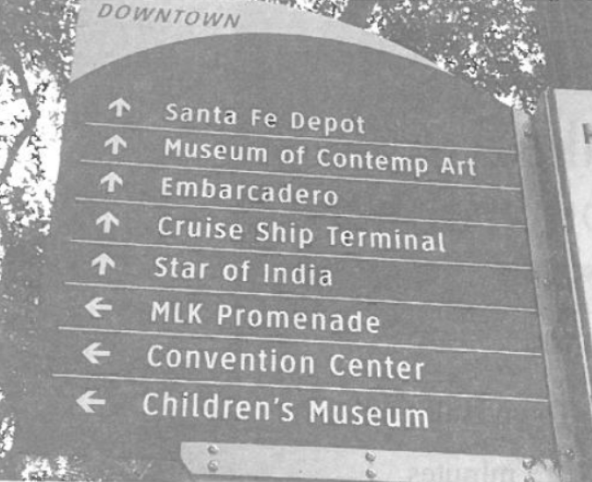

A. turn left B. turn right C. go straight ahead

【答案】C

【详解】句意：如果你想要参观印度星章（Star of India），你应该一直向前走。

考查看懂图片的信息。从图片中的Star of India方向箭头向前，可见如果想要参观印度星章（Star of India），你应该一直向前走（go straight ahead）。故选C。

17. We can infer from the sign that the library ________.

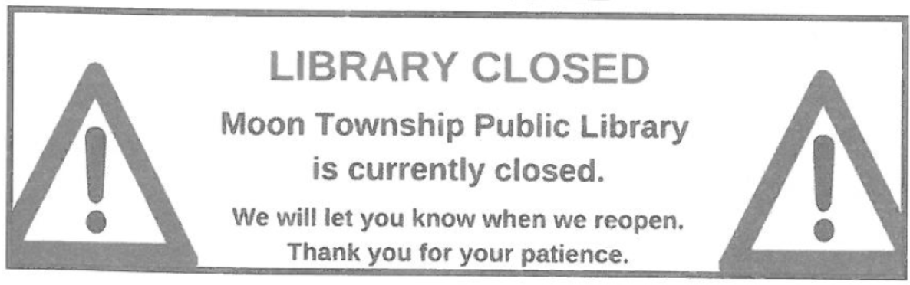

A. is closed only today B. stands close to Township C. might be under repair

【答案】C

【详解】句意：我们能从指示牌中推断出图书馆可能正在维修之中。

考查看懂图片的信息。从图片中的LIBRARY CLOSED (图书馆关闭中) 和We will let you know when we reopen（重开）. Thank you for your patience（谢谢你的耐心等待），以上信息能推断出图书馆不是只在今天关闭，目前是关闭的，所以图书馆可能正在维修之中。故选C。

18. What’s the lowest temperature next Saturday?

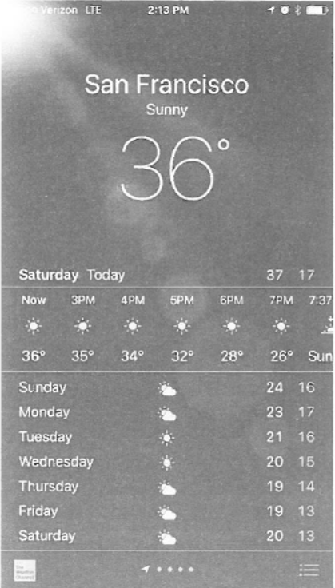

A. 20°. B. 17°. C. 13°.

【答案】C

【详解】句意：下周六的最低温度是多少？13°。

考查看懂图片的信息。从图片中的Sunday到Saturday中最右边的最低温度是13度。故选C。

19. The notice is meant to remind ________.

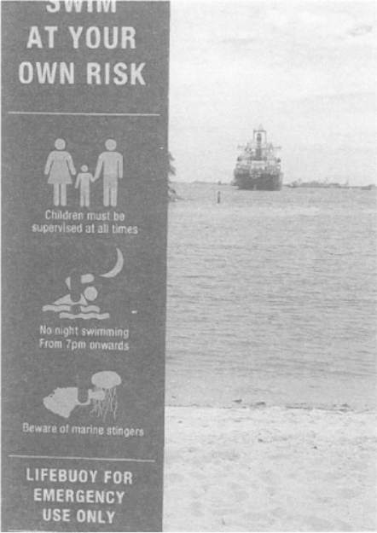

A. swimming lovers B. emergency lifeguards C. marine stingers

【答案】A

【详解】句意：通知的目的是提醒游泳者注意安全。

考查看懂图片的信息。从图片中的SWIM AT YOUR OWN RISK(自担风险游泳)和LIFEBUOY FOR EMERGENCY USE ONLY(救生圈只供紧急情况使用)，可见它的目的是提醒(swimming lovers) 游泳爱好者注意安全, 而不是提醒emergency lifeguards（紧急救生员）和Marine stingers（海蜇或有毒水母）。故选A。

20. How much do you have to pay if you buy four?



A. $2.50. B. $10.00. C. $12.50.

【答案】B

【详解】句意：如果你想要买四个，你要付多少钱？10美元。

考查看懂图片的信息。从图片中的$ 2.50 each (每个2.50美元) or 5 for $10,00 (5个10美元)，可见如果你想要买四个，你要付4*$2.5=$10。故选B。

21. What does the sign suggest?



A. Most items are sold at $1.50. B. Each item is marked at $1.50. C. All items are sold at $1.50.

【答案】A

【详解】句意：指示牌表明了什么？大部分商品商品1.50美元。

考查看懂图片的信息。从图片中的Most Items $1.50 Unless Price As Marked (大部分商品，除非标示价格，1.50美元)，可见大部分商品1.50美元。故选A。

22. Where are you most likely to see this?

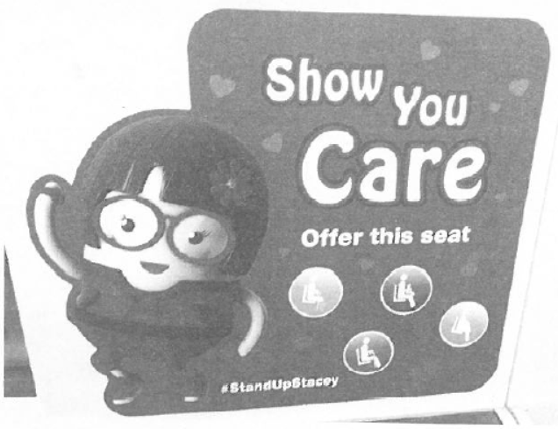

A. In a classroom. B. On a bus. C. By a lake.

【答案】B

【详解】句意：你最可能在哪里看到这个标志？在公共汽车上。

考查看懂图片的信息。从图片中的Show Your Care（表达你的关心）和Offer this seat（让座）可推断出最可能在公共汽车上看到以上标志。故选B。

Part B 根据下图所提供的信息，从23~25题所给的三个选项（A、B、C）中，选出最佳选项。

23. How long does it take to go from Museum Station to Town Hall Station?

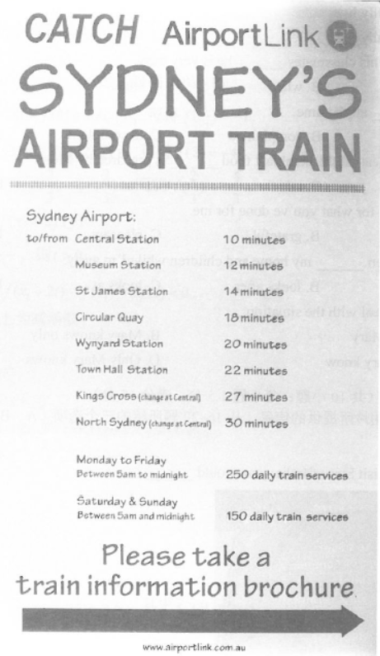

A. 10 minutes. B. 12minutes. C. 22minutes.

【答案】A

【详解】句意：从博物馆站到大会堂站要花多长时间？10分钟。

考查看懂图片的信息。从图片中的Sydney Airport (悉尼机场) to/from(往/返) Museum Station (博物馆站) 12 minutes (12分钟) Town Hall Station (大会堂站) 22 minutes (22分钟)，可知从博物馆站到大会堂站要花10分钟的时间。故选A。

24. Which day has the most daily train services?

A. Wednesday. B. Saturday. C. Sunday.

【答案】A

【详解】句意：哪一天火车班次最多？星期四。

考查看懂图片的信息。从图片中的Monday to Friday(从星期一到星期五) Between 5 am to midnight （上午5点到午夜）250 daily train service（250班次）和Saturday & Sunday(从星期六到星期天) Between 5 am and midnight （上午5点到午夜）150 daily train service（150班次）可知星期四 (从星期一到星期五)火车班次最多。故选A。

25. Which of the following is true?

A. The brochure is only for foreign visitors.

B. The train services work about 19 hours a day.

C. There are eight stations along the Airport Link.

【答案】B

【详解】句意：以下哪个选项是对的？火车服务每天工作大约19小时。

考查看懂图片的信息。从图片中的Monday to Friday(从星期一到星期五) Between 5 am to midnight （上午5点到午夜一共19个小时）和Saturday & Sunday(从星期六到星期天) Between 5 am and midnight （上午5点到午夜一共19个小时）， 可知火车服务每天工作大约19小时。故选B。

第二部分 阅读理解（5篇短文，共20小题；每小题2分，满分40分）

阅读下列短文，从每题所给的四个选项（A、B、C、D）中，选出最佳选项。

A

Dear friends,

We are having a party to celebrate our new school year. The party is on October 2, from 3-5 PM. It is going to be at Carla’s Cafe. We are going to play games, sing and dance. After that, we are going to eat dinner. Carla’s has great food!

Here are the directions from Lake School to Carla’s Cafe. First, turn right on Marconi Drive from the parking lot of the school. Stay on Marconi until the first traffic light, then turn right again. This is Lee Boulevard. Turn left at the corner of Lee Boulevard and Main Street. Stay on it for a mile. At Grand Park, Main Street changes to Canal Street. You should stay on Canal Street for twelve blocks. Finally, stop when you get to 3904 Canal Street. This is the Cafe. It is blue and white.

Please call and tell us if you can come to the party by September 15. My phone number is 555-7848. I really hope you can all come!

See you soon.

Avri

26. What kind of party are they planning?

A. A new school year party. B. A dance party.

C. A New Year party. D. A dinner party.

27. Where is Carla’s Cafe?

A. On Marconi Drive. B. On Canal Street. C. On Main Street. D. On Lee Boulevard.

28. Avri is most probably ________.

A. the manager of Carla’s Cafe B. the headmaster of Lake School

C. a student D. a parent

29. When should you call Avri if you have decided to go to the party?

A. Before October 2. B. Before October3.

C. Before September 5. D. Before September15.

【答案】26. A 27. B 28. C 29. D

【导语】本文是一篇通知，主要介绍了学生们将举行庆祝新学年的聚会及如何到达聚会地点。

26.细节理解题。根据信件内容的第一段的首句“We are having a party to celebrate our new school year.”可知，他们计划举行一场聚会来庆祝新学年，故选A。

27.细节理解题。根据信件内容的第二段“Finally, stop when you get to 3904 Canal Street. This is the Cafe.”可知，Carla’s Cafe在3904 Canal Street，故选B。

28.推理判断题。根据信件内容的开头“Dear friends, We are having a party----”可知，Avri 很可能是一个学生。故选C。

29.细节理解题。根据信件内容的最后一段“Please call and tell us if you can come to the party by September 15.”可知，如果你已经决定来参加聚会，你应该在9月15日之前打电话给Avri，故选D。

B

When Charley awoke one morning, he looked from the window and saw the ground deeply covered with snow. On the side of the house nearest to the kitchen, the snow was piled (堆积) higher than Charley’s head.

“We need a path through this snow,” said his father. “I would make one if I had time, but I must be at the office early this morning. Do you think you could make the path, son?” he asked little Charley.

“Me? The snow is higher than my head! How could I ever make a path through that snow?”

“How? By doing it little by little. How about you try?” said his father as he left for his office.

So Charley got the snow shovel (铲) and set to work. He threw up first one shovelful and then another; but it was slow work.

“I don’t think I can do it, Mom,” he said. “A shovelful is so little, and there is such a large pile of snow.”

“Little by little, Charley,” repeated his mother. “That snow fell in tiny bits, but you see what a great pile it has made.”

“Yes, Mom, I see,” said Charley. “If I throw it away little by little, it will soon be gone.”

So he worked on.

When his father came home to dinner, he was pleased to see the fine path. The next day he gave little Charley a fine sled (雪橇). Painted on it in yellow letters was “Little by Little”.

30. What did Charley see when he woke up?

A. The ground was full of deep snow. B. His mother was cooking in the kitchen.

C. His father was leaving for his office. D. It was snowing heavily.

31. Why did the father not make the path himself?

A. He had no problem going out. B. He had to go to work that morning.

C. He was going to buy a sled. D. He found it too boring to make it.

32. Why did Charley finally succeed in making the path?

A. His mother helped shovel the snow. B. He wanted the fine sled.

C. It stopped snowing that day. D. His mother encouraged him.

33. Which could be the best title for this passage?

A. Little by Little B. Charley and His Father

C. A Heavy Snow D. A Fine Sled

【答案】30. A 31. B 32. D 33. A

【导语】本文主要介绍了查理铲雪以开辟出一条新路来，雪堆得很大，妈妈鼓励她一点一点地铲，终于铲出一条小路。

30.细节理解题。根据第一段首句“When Charley awoke one morning, he looked from the window and saw the ground deeply covered with snow. ”可知，当查理醒来时，他看到了地上堆着厚厚的雪，故选A。

31.细节理解题。根据第二段“said his father. “I would make one if I had time, but I must be at the office early this morning.----”可知，他父亲不能自己开路的原因是因为他父亲那天早上很早就要上班，故选B。

32.推理判断题。根据倒数第四段““Little by little, Charley,”(一点一点来，查理) repeated his mother. “That snow fell in tiny bits, but you see what a great pile it has made.（雪落得很小，但你看，她堆成了一大堆）”可知，他的母亲的鼓励让他继续工作直至成功。故选D。

33.主旨理解题。全文主要介绍了查理一点一点地铲雪直到开辟出一条新路来，而文章的最后一段的The next day he gave little Charley a fine sled (雪橇). Painted on it in yellow letters was “Little by Little”，再次点明了文章的主题“Little by Little”。故选A。

C

A mother told me this story: Her two children, Josh, aged 7, and Heather, aged 5, were playing outside the house. After a few minutes, Heather came running into the house with tears on her face.

“Josh yelled (吼叫) at me and called me names,” she cried. Josh, who was close behind, said, “Well, you were acting like a fool!” The woman comforted Heather and then turned to Josh. “Josh, I want you to tell Heather you’re sorry for yelling at her. If you don’t like something Heather’s doing, all you have to do is tell her. There’s no need for yelling or name-calling. I want you to apologize to her.”

Josh looked up at her and said, “Well, you never apologize when you yell at me.”

The woman sat dumbstruck. Her son was right. She did yell at her kids (even though she was trying not to) and she didn’t apologize to them. She took Josh and Heather by the hands and told them, “You’re right, Josh. I do yell and I don’t apologize. I want you both to know that I am sorry I yell at you. I know it must hurt your feelings and I’m trying to stop. I’m going to try to do better.”

Josh smiled, “That’s okay, Mom. We all make mistakes.” Then he turned to Heather and said, “I’m sorry I yelled at you, Heather. You’ re not a fool. You’ re just a little kid.”

Moved with emotion, Heather gave her mother a big hug and said, “I love you, Mom.” Then she turned to Josh and said, “I love you too, Josh, even though you are rude to me sometimes.”

34. Why did Heather cry?

A. Josh refused to play with her. B. Josh acted like a fool.

C. Josh shouted at her. D. Josh fooled her.

35. Who said sorry first?

A. The author. B. The mother. C. Josh. D. Heather.

36. The underlined word “dumbstruck” in paragraph 3 probably means ________.

A. shocked and unable to speak B. pleased and eager to speak

C. sad and angry D. quiet and happy

37. The story tells us that ________.

A. brothers should take care of sisters B. parents should be models for children

C. males should respect females D. family members should help each other

【答案】34. C 35. B 36. A 37. B

【导语】本文主要介绍了一位母亲要她的小孩因吼叫或骂人而道歉，但她的小孩拒绝这样做，说母亲也曾这样做，母亲向小孩道歉，孩子们很感动。

34.细节理解题。根据第二段首句“Josh yelled (吼叫) at me and called me names,” she cried.可知，Heather哭的原因是因为Josh吼叫他，故选C。

35.细节理解题。根据第四段“I want you both to know that I am sorry I yell at you. I know it must hurt your feelings and I’m trying to stop. I’m going to try to do better.”可知，他们的妈妈先道歉，故选B。

36.猜词题。根据倒数第三段“She did yell at her kids (even though she was trying not to)（孩子们指出妈妈的错误感到震惊，而且的确发生过这样的事，妈妈不好说话） and she didn’t apologize to them.”可以猜出这位妇女坐着又震惊又不能开口，故选A。

37.主旨理解题。全文主要介绍了母亲要她的小孩因吼叫而道歉，但她的小孩拒绝道歉，说母亲也曾吼叫而没有道歉，后来母亲向小孩道歉，孩子们很感动，可以推断出父母应该成为小孩的模范，故选B。

D

The organization of our housing can be a mirror of our cultural requirements for space. British culture, for example, separates rooms into different uses so that people have the kitchen for cooking in, the dining room for eating in and the bedroom for sleeping in. They’re very protective of individual spaces and love to have their own bedrooms, their own chairs and their own secret drawers. This is very different in other cultures.

Jamaican houses usually have a big back yard and a front garden. People play a lot outside — more outside than inside. It is almost as if the whole neighborhood was their house or their home, so to speak-they have a big family and they are always into each other’s spaces — it is never private.

Arabs don’t have much space in public but they love to have big spaces inside their houses. They have large empty rooms with not much furniture because they don’t like to be alone — they like to be with each other inside these big spaces.

The Japanese, on the other hand, don’t have much physical space — they have very small apartments and houses. But what they do with the space is very clever. The spaces are multifunctional. So during the day they’ll have a sitting room where at night they’ll remove all the furniture and it becomes a bedroom. The typical Japanese house is basically one big room — could be the dining area, the living area, the place they entertain (招待) guests and then could be the guestroom or even the bedroom. The old generation hardly really had their own room when they were children — they shared the room, they always stayed with their parents. Parents knew everything.

38. The British people like to have ________.

A. small kitchens B. many mirrors C. private spaces D. big chairs

39. Jamaican houses ________.

A. have much space in public B. have many gardens

C. have different back yards D. have much private space

40. The Japanese people ________.

A. are good at room services B. like to be with each other inside

C. provide no furniture in children’s rooms D. use the same space for different purposes

41. What’s the main idea of the passage?

A. The design of houses is a work of art. B. The building of houses is a long process.

C. The use of house space is related to culture. D. The size of rooms is based on practical needs.

【答案】38. C 39. A 40. D 41. C

【导语】本文主要介绍了住房的组织反映出我们对空间的文化要求并举例不同的国家的人如英国人、牙买加人、阿拉伯人、日本人对物理空间有不同的要求。

38.细节理解题。根据第一段“British culture, for example, separates rooms into different uses so that people have the kitchen for cooking in, the dining room for eating in and the bedroom for sleeping in. They’re very protective of individual spaces (他们非常保护个人空间) and love to have their own bedrooms, their own chairs and their own secret drawers（喜欢有自己的卧室，自己的椅子和自己的秘密抽屉）. ”可知，英国人喜欢有私人空间，故选C。

39.细节理解题。根据第四段“they have a big family and they are always into each other’s spaces-it is never private ”可知，牙买加人的房子很多公共的地方，故选A。

40.细节理解题。根据最后一段“ The spaces are multifunctional（多功能的）. So during the day they’ll have a sitting room where at night they’ll remove all the furniture and it becomes a bedroom. ”可见日本人把同样的空间用于不同的目的，故选D。

41.主旨理解题。全文主要介绍了住房的组织反映出人们对空间的文化要求并举例不同的国家的人对物理空间有不同的要求，所以这篇文章的主要意思是住房空间的使用跟文化是有关联的，故选C。

E

Zuogong County is located in southeastern Tibet, China. The whole county has only one middle school, Zuogong County Middle School.

Su Xin is the headmaster of the school. He is from Liangshan, Sichuan Province. His wife, Gan Runmei is also from Sichuan. She is now an English teacher at the school. They both came to Tibet to teach after graduating from university in 2001. In 21 years, the school has changed a lot.

When they first came to the school, over a hundred students could only speak Tibetan. Su Xin spent a month learning Tibetan and teaching students Putonghua so they could communicate. The farthest town, Bitu, is more than 160 kilometers from the school. In the past, it took students three days to walk to school. “And there was only one teaching building,” said Su.

With the help of the government, new roads were built and the school’s condition has been improved. Now the government provides the students free traffic service from home to school.

After four periods of construction, the school now has 15 school buildings and a standard playground. More parents have come to realize the importance of education, so the number of students in the school has increased to 1,500.

Due to the long distance from home to school, most students in Tibet can only go home once a term. Teachers at school need to take care of all aspects of their students’ lives. “We are not only the students’ teachers, but also their parents,” said Gan.

Thus, it is a pity that the couple can’t stay with their children and parents back in Sichuan. There are fewer than 100 days in a year for them to be together.

But it is because of a group of people like them spending more time with their students instead of their family that education in remote areas can improve.

42. What do we know about Gan?

A. She graduated from university 15 years ago. B. She helped build the standard playground.

C. She is the headmaster of the school. D. She is an English teacher.

43. Why can Su and Gan stay with their family for no more than 100 days a year?

A. They have to go back home on foot.

B. It is too far away for them to go home.

C. Their children and parents can take care of themselves.

D. They have to spend more time taking care of their students.

44. The underlined word “them” in the last paragraph refers to ________.

A. Su and Gan B. Su and Gan’s parents and children

C. the students D. the teachers

45. This is a ________.

A. book review B. school introduction C. news report D. letter of praise

【答案】42. D 43. D 44. A 45. C

【导语】本文主要介绍了左贡县中学的发展历程和校长夫妇为改变偏远地区的教育所付出的努力和贡献。

42.细节理解题。根据第一段“ His wife, Gan Runmei is also from Sichuan. She is now an English teacher at the school（学校里的一个英语老师）. ”可知，Gan是一个英语老师，故选D。

43.细节理解题。根据第四段“ Teachers at school need to take care of all aspects of their students’ lives. “We are not only the students’ teachers,but also their parents,” said Gan.可知，校长夫妇一年内没有100天的时间跟他们的家人待在一起是因为他们花很多的时间照顾他们的学生，故选D。

44.推理判断题。根据最后一段“But it is because of a group of people like them spending more time with their students instead of their family that education in remote areas can improve. ”可见下划线的 them指校长夫妇，故选A。

45.主旨理解题。全文主要介绍了左贡县中学的发展历程和校长夫妇为改变偏远地区的教育所付出的努力和贡献。可见本文不是一篇书评，学校介绍，表扬信，而是一篇新闻报道，故选C。

**第Ⅱ卷（共三节 满分30分）**

**注意事项：**

**1.必须使用0. 5毫米黑色墨迹签字笔在答题卡上题目所指示的答题区域内作答。**

**2. 第Ⅱ卷共三节，满分30分。**

第一节 补全对话（共5小题；每小题1分，满分5分）

阅读下列对话，从所给选项中，选出能够完成对话的最佳选项。选项中有两个多余选项。

(*Mary is shopping for a dress. A saleswoman helps her pick one out.*)

A: Good morning, ma’am. 46

B: Yes, I’d like to see one of those dresses.

A: You mean this one?

B: Yes. 47

A: It’s silk.

B: May I try this one on?

A: Certainly. 48

B: Six.

A: 49 The fitting rooms are over there.

(*A few minutes later, Mary comes back from the fitting room.*)

A: How does it fit?

B: 50 I’ll take it.

|  |
| --- |
| A. Perfectly.  B. No problem.  C. Here you are.  D. What do you want?  E. What is it made of?  F. What size do you wear?  G. Is there anything I can do for you? |

【答案】46. G 47. E 48.F 49. C 50. A

【导语】本文是玛丽与女售货员的情景对话，讲的是女售货员帮玛丽挑选裙子。

46.根据“Yes, I’d like to see one of those dresses（是的，我想要看裙子）.”可知，女售货员问玛丽是否需要服务，这是购物的常用开头语。G. Is there anything I can do for you? “我能为你做点什么？”符合情景。故选G。

47.根据“ It’s silk（它是丝的）.”可知，E项What is it made of?“它是用什么做成的”符合情景。故选 E。

48.根据“Six.”可知，在它的前面女售货员问玛丽穿什么尺寸的，F项What size do you wear? “你穿什么尺寸的？”符合情景。故选F。

49.玛丽挑好裙子的尺寸后，女售货员会把裙子拿给玛丽试穿，C项 Here you are.“给你。”符合情景。故选 C。

50.根据前面的“How does it fit?（合身吗？）”，后面的回答应是A项Perfectly.“完美。”符合情景。故选A。

第二节 翻译（共5小题；每小题2分，满分10分）

Part A 请将下面的英语句子翻译成汉语。

51. Practice makes perfect.

【答案】熟能生巧。

【详解】句意：熟能生巧。

本题考查翻译技巧。主谓宾结构。主语是Practice，谓语是makes， 宾语是perfect（完美）；结合谚语，可译为“熟能生巧”。

52. I speak only when they are ready to hear.

【答案】我只在他们准备听的时候讲话。

【详解】句意：我只在他们准备听的时候讲话。

本题考查翻译技巧。主谓结构。主语是 I，谓语是speak， 后面的only when they are ready to hear是时间状语从句， 可译为“只在他们准备听的时候”；所以整句可译为“我只在他们准备听的时候讲话”。

53. Beijing is the world’s first city to have held both the Summer and the Winter Olympic Games.

【答案】北京是世界上第一个举办过夏季和冬季奥运会的城市。

【详解】句意：北京是世界上第一个举办过夏季和冬季奥运会的城市。

本题考查翻译技巧。主系表结构。主语是Beijing ，谓语是is，表语是the world’s first city to have held both the Summer and the Winter Olympic Games（世界上第一个举办过夏季和冬季奥运会的城市）， the world’s first city后面的 to have held both the Summer and the Winter Olympic Games是不定式， 它作定语修饰前面的the world’s first city， 可译为“举办过夏季和冬季奥运会的世界上第一个城市”；所以整句可译为“北京是世界上第一个举办过夏季和冬季奥运会的城市”。

Part B 请根据所给中文提示，将下列译成英语的句子补充完整。

54. 你锻炼得越多，身体就越强壮。

The more you exercise, ________ ________ you will be.

【答案】the；stronger

【详解】句意：你锻炼得越多，身体就越强壮。The+比较级，the+比较级 “越-------越------”， 故填the；stronger。

55. 没有我的位置了。所有的座位都被占了。

There is no room for me. All the seats________ ________.

【答案】are；taken

【详解】句意：没有我的位置了。所有的座位都被占了。座位都被占，是被动语态，故填are；taken。

第三节 书面表达（满分15分）

假如你叫李华。上个月你从某外网购买了三本书，收到后不满意。现在你用英语给该网站写封邮件。内容包括：

1.书籍存在的问题；

2.你的诉求。

注意：

1.词数80左右；

2.可以适当增加细节，使行文连贯；

3.文章开头已为你写好，不计入总词数。

Dear Sir/Madame,

I’m Li Hua, a regular customer of your website. ______________________________________________________________________________________________________________________________________________

Thank you.

Yours,

Li Hua

【答案】例文：

Dear Sir/Madame,

I’m Li Hua, a regular customer of your website. I’m writing to complain about the three books I bought from your online store on April 19th.

Receiving them, I could hardly open them, only to find that some contents were printed so poorly that I couldn’t read them. Besides, twenty pages of one book were missing, which made me very annoyed.

I would appreciate it if you could exchange the three books for new ones, or I will declare a full refund. I hope that my problem can get your kind consideration.

Thank you.

Yours,

Li Hua

【详解】**[总体分析]**

①题材：本文是一篇投诉信邮件；

②时态：时态以“一般过去时”为主；

③提示：写作要点已给出，注意不要遗漏内容要点，可适当添加细节，并突出写作重点。

**[写作步骤]**

第一步，承接所给开头，介绍写信的目的；

第二步，具体阐述投诉的具体内容；

第三步，期盼投诉能得到有效的处理。

**[亮点词汇]**

1.complain about抱怨

2.only to find that 却发现

3.so --- that--- 如此------以致------

4.made me very annoyed 让我很恼火

5.exchange the three books for new ones把这三本书换成新的

6.declare a full refund宣布全额退款

7.get your kind consideration 得到你的关照

**[高分句型]**

1.I’m writing to complain about---- 我写信是为了抱怨-----

2.Some contents were printed so poorly that I couldn’t read them. 有些内容印得很糟糕以致我无法阅读。

3.twenty pages of one book were missing, which made me very annoyed. 有一本书少了20页，这让我很恼火

4.I would appreciate it if you could 如果你能------，我将非常感激。